CMSC/CIS 255 Fall 2016
Homework 3 Solution
SELECT (150 points available)
Deadline: Midnight MON SEP 19

- Find the highest and lowest StandardPrice in Purchasing.ProductVendor. (10 points)

Solution One:

SELECT MIN(StandardPrice) AS Cheapest,
MAX(StandardPrice) AS MostExpensive
FROM Purchasing.ProductVendor;

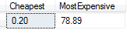

Solution Two (2 separate queries):

Lowest:
SELECT TOP 1 StandardPrice
FROM Purchasing.ProductVendor
ORDER BY StandardPrice;

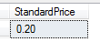

Highest:
SELECT TOP 1 StandardPrice
FROM Purchasing.ProductVendor
ORDER BY StandardPrice DESC;

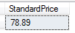

NOTE: Obviously Solution One is simpler. But the advantage of Solution Two is that, by adding additional columns such as ProductID, it can show the cheapest and most expensive product information, not just the price.

- Show the number of employees and the average vacation time for married men, married women, single men, and single women in the HumanResources.Employee table. List the results in ascending order by average vacation time. (15 points)

SELECT MaritalStatus, Gender,
AVG(VacationHours) AS AverageVacationHours,
COUNT(MaritalStatus) AS Number
FROM HumanResources.Employee
GROUP BY MaritalStatus, Gender
ORDER BY AverageVacationHours;

4 rows
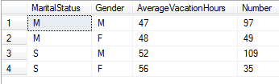

- Find the customer IDs of all customers in the Sales.Customer table who have not shopped at a store with StoreID larger than 500. Customers whose StoreID is not known should be included. (10 points)

NOTE: StoreID does not have to be included in the query below; I just included it for verification. But you must have the StoreID IS NULL part in the WHERE.

SELECT CustomerID, StoreID
FROM Sales.Customer
WHERE StoreID <= 500 OR StoreID IS NULL;

18677 rows
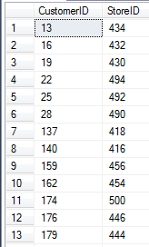
- Find all the products in Production.Product whose name contains:
- The word ‘Tire’. (10 points)

SELECT Name
FROM Production.Product
WHERE Name LIKE '%Tire%';

10 rows
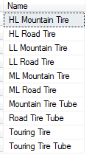

- The words ‘Hex Nut’ followed by a two-digit number. (10 points)

SELECT Name
FROM Production.Product
WHERE Name LIKE '%Hex Nut [1-9][0-9]%';

21 rows
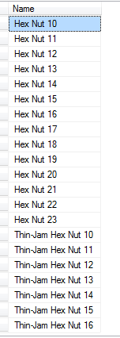

- (a) Use the Purchasing.ProductVendor table to find all products (i.e. ProductIDs) purchased from only one vendor. The vendor is shown by the BusinessEntityID column.
(10 points)
SELECT ProductID
FROM Purchasing.ProductVendor
GROUP BY ProductID
HAVING COUNT(BusinessEntityID) = 1;

113 rows
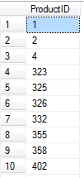

(b) Now show all the BusinessEntityIDs of vendors who supply only one product.
(10 points)
SELECT BusinessEntityID
FROM Purchasing.ProductVendor
GROUP BY BusinessEntityID
HAVING COUNT(ProductID) = 1;

29 rows
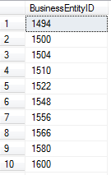

- Show the Name, CountryRegionCode, and Continent of all rows in the table Person.StateProvince.
The Continent column depends on the CountryRegionCode in the following way: it should be ‘North America’ if the CountryRegionCode is either US or CA, otherwise it should be ‘Outside North America’. (10 points)

There are many solutions. Here are three.

SELECT Name, CountryRegionCode,
IIF(CountryRegionCode = 'US' OR CountryRegionCode = 'CA',
'North America', 'Outside North America') AS Continent
FROM Person.StateProvince;

SELECT Name, CountryRegionCode,
CASE CountryRegionCode
WHEN 'US' THEN 'North America'
WHEN 'CA' THEN 'North America'
ELSE 'Outside North America'
END AS 'Continent'
FROM Person.StateProvince;

SELECT Name, CountryRegionCode,
CASE
WHEN CountryRegionCode = 'US' OR CountryRegionCode = 'CA'
THEN 'North America'
ELSE 'Outside North America'
END AS 'Continent'
FROM Person.StateProvince;

181 rows
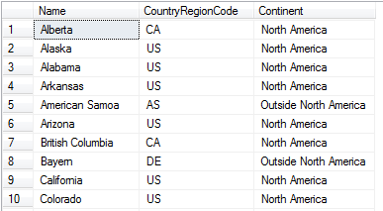

- (a) Show the SalesOrderID, OrderDate, DueDate and ShipDate of all orders in the Sales.SalesOrderHeader table which were ordered in either February or September of any year from 2011 to 2013. (10 points)

There are many ways to write the WHERE clause – here are 5 of them. Notice that the Year and Month can be compared to integers or strings.

SELECT SalesOrderID, OrderDate, DueDate, ShipDate
FROM Sales.SalesOrderHeader
WHERE (MONTH(OrderDate) = '02' OR MONTH(OrderDate) = '09')
AND YEAR(OrderDate) BETWEEN 2011 AND 2013;

SELECT SalesOrderID, OrderDate, DueDate, ShipDate
FROM Sales.SalesOrderHeader
WHERE 2011 <= YEAR(OrderDate) AND YEAR(OrderDate) <= 2013 AND
(MONTH(OrderDate) = 02 OR MONTH(OrderDate) = 9);

SELECT SalesOrderID, OrderDate, DueDate, ShipDate
FROM Sales.SalesOrderHeader
WHERE MONTH(OrderDate) IN (2, 9) AND YEAR(OrderDate) IN (2011, 2012, 2013);

SELECT SalesOrderID, OrderDate, DueDate, ShipDate
FROM Sales.SalesOrderHeader
WHERE ('2011-02-01' <= OrderDate AND OrderDate < '2011-03-01') OR
('2011-09-01' <= OrderDate AND OrderDate < '2011-10-01') OR
('2012-02-01' <= OrderDate AND OrderDate < '2012-03-01') OR
('2012-09-01' <= OrderDate AND OrderDate < '2012-10-01') OR
('2013-02-01' <= OrderDate AND OrderDate < '2013-03-01') OR
('2013-09-01' <= OrderDate AND OrderDate < '2013-10-01');

NOTE: Direct pattern-matching using WHERE OrderDate LIKE '201[1-3]-0[29]%' doesn’t work, because OrderDate is a date, which does not match the string. The OrderDate needs to be converted to a string explicitly. One way to do this is using CONVERT. The 3rd argument, the number 21 in this example, specifies the date format.

SELECT SalesOrderID, OrderDate, DueDate, ShipDate
FROM Sales.SalesOrderHeader
WHERE CONVERT(VARCHAR(20), OrderDate, 21) LIKE '201[1-3]-0[29]%';

2844 rows
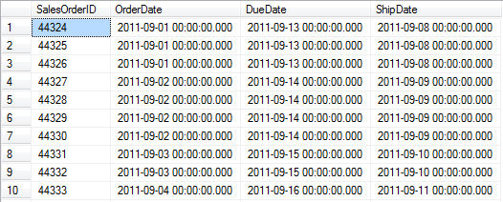
- Show the SalesOrderID, OrderDate, DueDate and ShipDate of all orders in the Sales.SalesOrderHeader table that were shipped more than 1 week after they were ordered. (10 points)
Hint: The DATEDIFF function may be useful.

Here are 2 solutions, one using more than 7 days, the other using more than 1 week. They give different results. (Why?)

Solution 1:

SELECT SalesOrderID, OrderDate, DueDate, ShipDate
FROM Sales.SalesOrderHeader
WHERE DATEDIFF(day, OrderDate, ShipDate) > 7;

9 rows
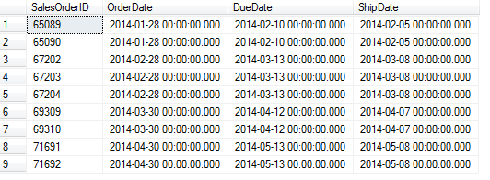

Solution 2:

SELECT SalesOrderID, OrderDate, DueDate, ShipDate
FROM Sales.SalesOrderHeader
WHERE DATEDIFF(week, OrderDate, ShipDate) > 1;

There are no results.
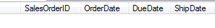
- Show all the credit-card-numbers in Sales.CreditCard that start with either a 1 or a 9 and whose second-last-number is even. (10 points)

SELECT DISTINCT CardNumber
FROM Sales.CreditCard
WHERE CardNumber LIKE '[19]%[02468]_';

NOTE: DISTINCT should probably be used here, since we probably don’t want to see the same credit card more than once. It’s ok if you left it out. But start trying to get into the habit of always considering whether duplicates should be included or not.

2329 rows
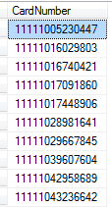

- Determining determining.

To select the primary key (and to handle normalization later in the semester), we want to determine if one column (or set of columns), determines another column (or set of columns). For example, consider the Purchasing.ProductVendor table. We notice from rows 4 and 5 that ProductID does NOT determine BusinessEntityID. But rather than relying on visual observation, we need a query to determine this.

- Write a query that shows how many different BusinessEntityIDs each ProductID has. Then add a filter to show only the ProductIDs that have more than one corresponding BusinessEntityID. Because the query has a non-empty result, we can conclude that ProductID does not determine BusinessEntityID. (10 points)

SELECT ProductID, COUNT(DISTINCT BusinessEntityID) AS DependentCount
FROM Purchasing.ProductVendor
GROUP BY ProductID
HAVING COUNT(DISTINCT BusinessEntityID) > 1;

NOTE: Here is is very important that the query has DISTINCT, and it should occur in two places in the query. It doesn’t make any difference to this result, but it would have if any product had occurred in multiple rows with the same BusinessEntityID.
152 rows (So ProductID does NOT determine BusinessEntityID)
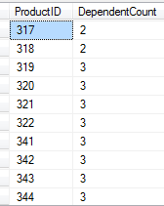

- Write a similar query that shows all the ProductIDs that have more than one corresponding MinOrderQty. Because the query has an EMPTY result, we can conclude that ProductID DOES DETERMINE MinOrderQty. (10 points)

SELECT ProductID, COUNT(DISTINCT MinOrderQty) AS DependentCount
FROM Purchasing.ProductVendor
GROUP BY ProductID
HAVING COUNT(DISTINCT MinOrderQty) > 1;

0 rows (So ProductID determines MinOrderQty)
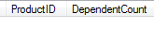
NOTE: Here the DISTINCT makes all the difference. For example, there are 2 rows with ProductID 317, but both of them have the SAME MinOrderQty.

- Using a similar approach, work out whether BusinessEntityID determines AverageLeadTime. (5 points)

SELECT BusinessEntityID,
COUNT(DISTINCT AverageLeadTime) AS DependentCount
FROM Purchasing.ProductVendor
GROUP BY BusinessEntityID
HAVING COUNT(DISTINCT AverageLeadTime) > 1;

6 rows (So BusinessEntityID does NOT determine AverageLeadTime)
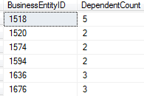

NOTE: A similar query, which I didn’t ask for, shows that ProductID doesn’t determine AverageLeadTime either.

- Using a similar approach, work out whether ProductID and BusinessEntityID combined determine AverageLeadTime. (5 points)

SELECT ProductID, BusinessEntityID,
COUNT(DISTINCT AverageLeadTime) AS DependentCount
FROM Purchasing.ProductVendor
GROUP BY ProductID, BusinessEntityID
HAVING COUNT(DISTINCT AverageLeadTime) > 1;

0 rows (So ProductID and BusinessEntity combined determine MinOrderQty, even though each on its own does not. This is similar to INV_NUM and PROD_NUM on HW1 #9.)
